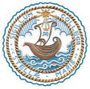
STELLA MARIS COLLEGE (AUTONOMOUS)
CHENNAI-600 086

Tel : 044 – 28110121
Email : principal@stellamariscollege.edu.in
Web : stellamariscollege.edu.in

31 January 2022

National Voters Day
The administration staff and faculty of Stella Maris College observed National Voters Day on 25th and 27th January 2022 respectively.
Standard operating procedures and guidelines provided by the Government was followed while conducting the pledge on campus.

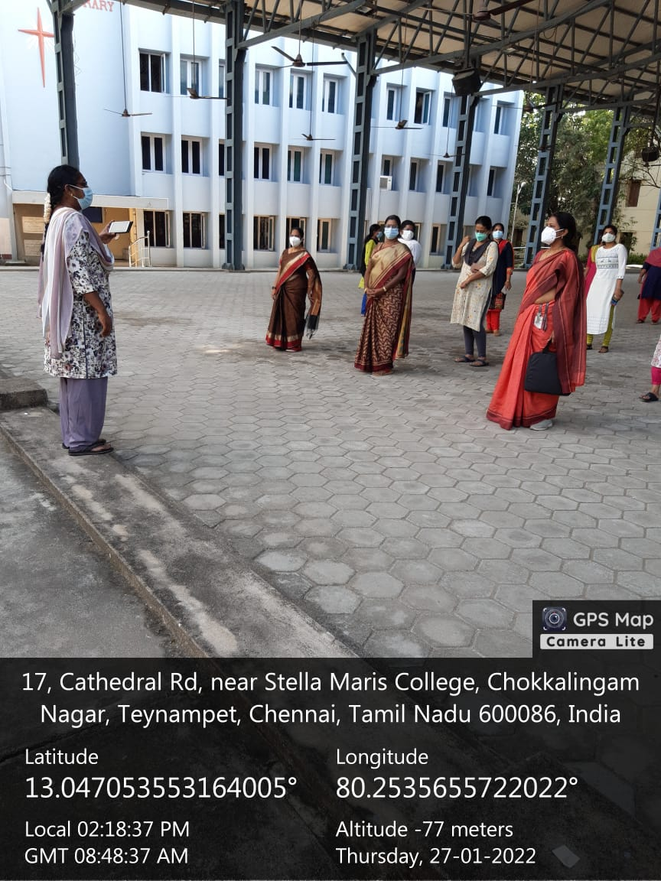
In pictures: Faculty taking the National Voters Day pledge




